Caitlyn Jones
Prof. Yangyang Wang
MATH 40A: Intro to Applied Math
18 October 2024
Lab 3
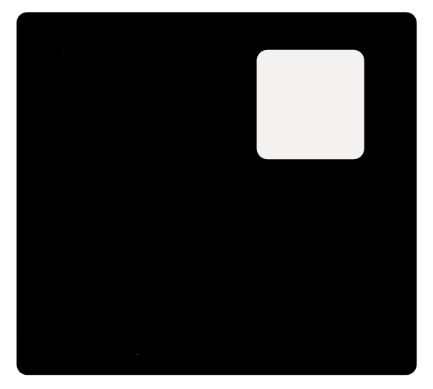
- This is my sketch on paper based on the code in test_image.py.

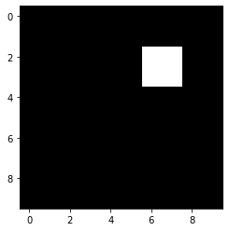
This is the output of running test_image.py.

- To create function makesquare(), I needed to input four variables: the original image, the upper left corner of the square, the size of the square, and the shade of the square. Then, I needed to create the square using the upper left corner as the starting point of the new square with the different shade.
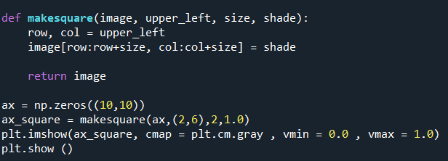

My output image was the same as question 1, as expected.

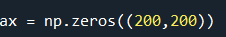
- To make the leftmost image, I first created the 200 x 200 image with a black background.

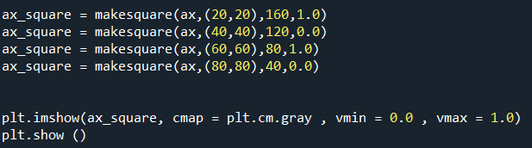
Then, I made four alternating white and black squares, up to scale.

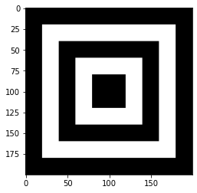
Here is the desired output.

To make the rightmost image, I created a function makesquare_large(image, x, y), where x is tracking the coordinates and y is tracking the size of the square.
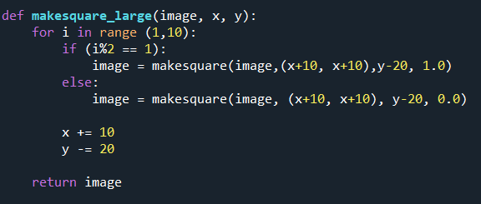

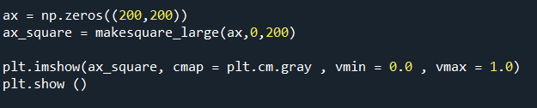
Here is the desired output.

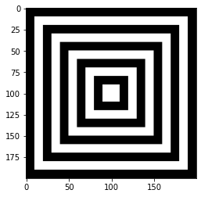

- The algorithm fails because in images with small horizontal lines, the neighboring pixels will also be affected by the noise. Instead, I did the following.
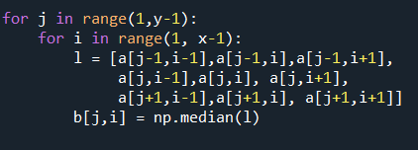

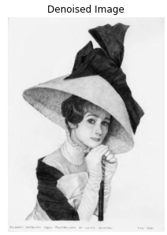
To get the following denoised image.

